

Fixing Data Sheet for Premier Fence Posts (Ground Fix)

Thank you for choosing our fencing system for your garden, the following information should be read prior to installation and if you have any questions after reading through these instructions then please do give us a call.

Your delivery should contain all that you require to install your run of fencing, various small components will be found inside the post packages. If you think anything is missing please contact us as soon as possible.

The first step is to set out your fencing, we recommend that you lay the posts on the ground and adjust the intervals to give a balanced run of posts. We suggest about 1.75 to 2.5 meters between posts but you may need to adjust these measurements so you do not end up with a small or large gap at one end.

Before you install your posts into the ground you should remove the caps (Please knock them from the inside of the post with a broom handle or similar to avoid damage). As you have chosen the ground fix posts you are going to excavate a hole for each post, the recommended method of installation would be to put a small amount of concrete around the base of each post and place 12 inch of post in the ground. (Before you do this you should locate the section of UPVC tube through the hole in the bottom of each post as this will stop the post being lifted out of the concrete once set.)

To install the chain into an end post you should feed the end of your chain through the chain hole in the post and pull it up through the top of the post, now take two of the joining links supplied and clip them both onto the very end link of your chain as in the photo and drop this back inside the post and replace the cap. You may now feed the chain through the remaining posts by gently pulling it until the desired droop in the chain is achieved but do not replace the caps on these posts at the moment.

End Post termination 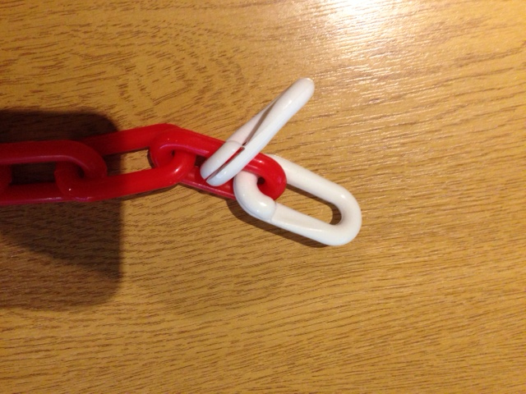 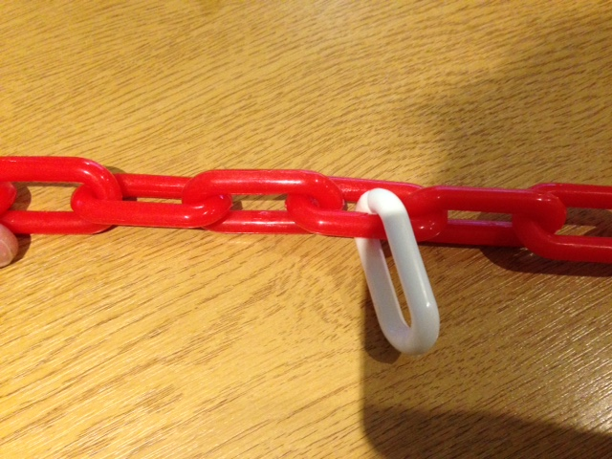Intermediate Post Clip

You will note that you also have a split link with each intermediate post, this link will be used to stop the chain dragging through the posts and becoming uneven. Once you have put up your posts and set the chain exactly as you would like it, go to each intermediate post in turn and apply the split link as in the photo to a link of chain inside the post and this will stop the chain moving left/right.

You will also have received a joining link to accompany each corner or ‘T’ post. Although you can pass the chain through the corner posts, it would be laborious with a great length of chain and so we suggest that once you have identified the location of the corner you cut the chain and utilise the joining link supplied at this point.

Finally, replace all the post caps by gently tapping them in with something which will not damage them as you do so.

If you have any difficulty or require any advice you can call us on 0345 017 9768 from 8.30am – 4.30pm Monday - Friday.

We love to see our customers finished projects, if you would like to email us a photo or two please send them to: sales@thelittlepostandchaincompany.co.uk

