

Fixing Data Sheet for Premier Fence Posts (Socket Fixing)

Thank you for choosing our fencing system for your garden, the following information should be read prior to installation and if you have any questions after reading through these instructions then please do give us a call.

In your delivery you should have all that you require to install your run of fencing, various small components will be found inside the post packages. If you think anything is missing please contact us as soon as possible.

The first step is to set out your fencing, we recommend that you lay the posts or sockets on the ground and adjust the intervals to give a balanced run of posts. We suggest about 1.75 to 2.5 meters between posts but you will need to adjust these intervals so you do not end up with a small or large interval at one end.

Once you have decided on the post locations you can either concrete the sockets in position or use the extended socket section included to form the hole for your sockets. If the ground is soft enough this will be straight forward, but if it is hard and dry you may find that soaking the area with water may help. Place a piece of wood over the top of the hole former section and drive it into the ground some 3 inches, tap and shake the hole former and then remove it with a core of soil. Repeat this exercise a couple more times taking a further three inches of soil out each time. The hole you make should be 3 inches shallower than the socket which you are going to put into the hole. This ensures that when you do place the socket into the hole you have made, you will need to hammer it in the final 3 inches, by doing so the bottom 3 inches of the socket will have embedded into the soil for extra sturdiness.

Insert a depth limit pin into the hole in one side of the socket and push it through so that it protrudes evenly on each side of the socket, this pin will stop your fence post from sinking through the socket and into the ground. Now place the socket into the hole you have made previously and again place a piece of wood over the top and tap the socket into the ground so that its top is flush with or slightly below the ground level. (The end of the socket nearest the plastic pin should go into the ground 1st)

The posts can now be dropped into the sockets.

To install the chain we recommend you first remove all the post caps by knocking them from the inside with a broom handle or similar to avoid damage. Starting with an end post feed the end of your chain through the hole in one end post and pull the chain up through the top of the post, now take two of the joining links supplied and clip them both onto the very end link of your chain as in the photo and drop this chain back into the post and replace the cap. You may now continue to feed the chain through the remaining posts by gently pulling it until the desired droop in the chain is achieved.

End Post Termination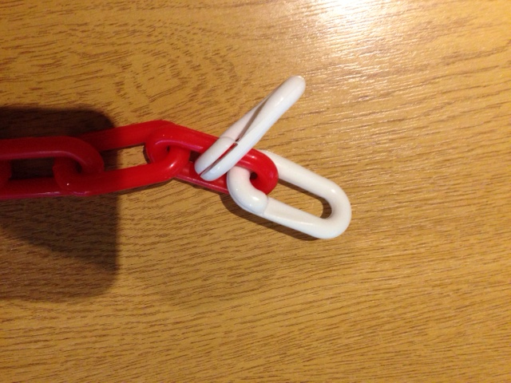 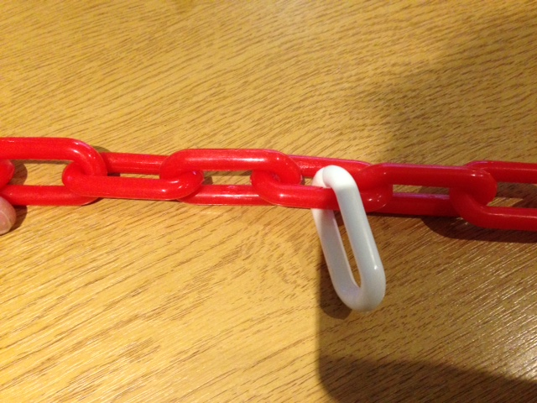Intermediate Post Clip

You will note that you also have a split link for each intermediate post, this link will be used to stop the chain dragging through the posts and becoming uneven. Once you have put up your posts and set the chain exactly as you would like it, then go to each post in turn and apply the split link as in the photo to a link of chain inside the post and this will stop the chain from moving left/right.

You will also have received a joining link to accompany each corner or ‘T’ post. Although you can pass the chain through the corner posts, it would be laborious with a great length of chain and so we suggest that once you have identified the location of the corner you cut the chain and utilise the joining link supplied at this point.

If you have any difficulty or require any advice you can call us on 0345 017 9768 from 8.30am – 4.30pm Monday - Friday.
We love to see our customers finished projects, if you would like to email us a photo or two please send them to: sales@thelittlepostandchaincompany.co.uk

