

Fixing Data Sheet for Temporary Fence Posts

Thank you for choosing our fencing system, the following information should be read prior to installation and if you have any questions after reading through this information then please do give us a call.

Your delivery should have all that you require to install your run of fencing, various small components will be found inside the post packages. If you think anything is missing please contact us as soon as possible.

The first step is to set out your fencing, we recommend that you tap the wooden stakes into the ground lightly first and adjust the intervals to give a balanced run of posts. We suggest about 1.0 to 1.75 meters between posts but you will need to adjust these measurements so you do not end up with a small or large interval at one end.

Once you are happy with the spacing you can drive the wooden stakes into the ground. DO PLACE A PIECE OF WOOD OVER THE TOP OF THE STAKES WHEN DRIVING THEM IN TO THE GROUND SO AS NOT TO DAMAGE THE TOP OF THE STAKE, SO THAT THE UPVC POST WILL NOT FIT OVER IT. Drive each post in to the ground until about 12 inches is protruding above ground level then drop the UPVC post over the stake. A screw and cover cap is supplied so that you can secure the UPVC post to the wooden stake at the end of the installation.

BEFORE YOU FIX THE POSTS WITH THE SCREWS WE RECOMMEND YOU REMOVE THE CAPS. (This is best done with a broom handle placed within the post to knock it out)

Starting with an end post feed the end of your chain through the hole in one end post and pull it up through the top of the post, now take two of the joining links supplied and clip them both onto the very end link of your chain as seen in the photo and drop this back into the post. You may now feed the chain through the remaining posts by gently pulling it until the desired droop in the chain is achieved. In your packs of intermediate posts you will have 1 split link per post, once you have set the chain as required you can push a split link onto a link of chain INSIDE each post as seen in the photo before replacing all of the caps. This split link will stop your chain from being pulled left/right through the post and becoming unbalanced.
End Post Termination 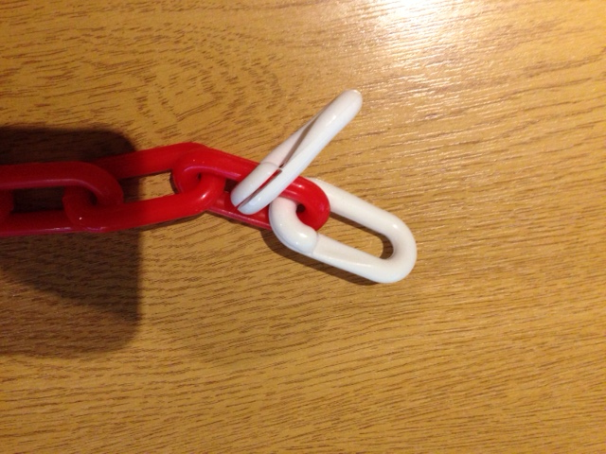 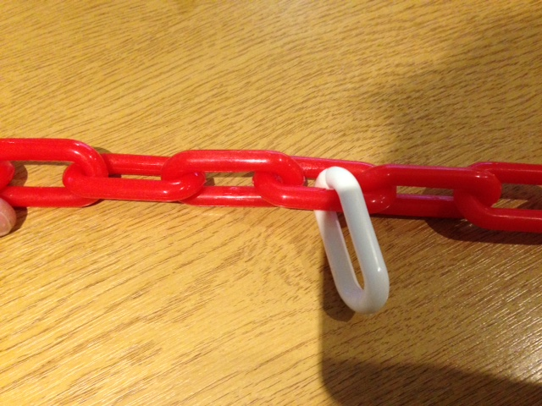Intermediate Post Clip

You will also have received a joining link to accompany each corner or ‘T’ post. Although you can pass the chain through the corner posts, it would be laborious with a great length of chain and so we suggest that once you have identified the location of the corner you cut the chain and utilise the joining link supplied at this point.

If you have any difficulty or require any advice you can call us on 0345 017 9768 from 8.30am – 4.30pm Monday - Friday.

We love to see our customers finished projects, if you would like to email us a photo or two please send them to: sales@thelittlepostandchaincompany.co.uk

